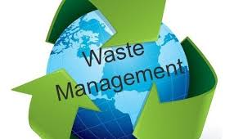
EUMIND – PHASE IV

WASTE MANAGEMENT

SUMMARY

TEAM MEMBERS

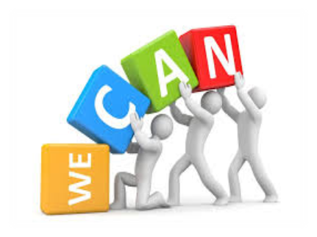
Tia Dhanote

Drishti Jangid

Punya Shingadia

Suhani Jaiswal

Aaloki Ghaghda

Similarities

students of netherlands and india are aware as
well as conscious about saving our environment and managing waste.

pupils from both the places do adopt the method of segregating waste into dry and wet waste.

students in both the countries have taken major
initiative in bringing awareness and generating less amount of waste.

students working on this project have understood
the importance of waste management in order to keep environment clean and hygenic.

Differences

students of netherland follow the
pattern of not generating much of waste material.

they have different methods of
decomposing and managing their waste.

in india we produce organic manure from the waste generated by society.

CONCLUSION

A Video Conference with students of Berlage Lyceum of Netherland on 11th December, 2020 was a wonderful interactive session.
We got to learn about the technicalities of waste management in foreignland.
As the proverb says ‘Cleaniness is next to Godliness', we learned that we should always keep our surroundings clean to stay healthy and fit.
 The Government in India is taking lot of initiative towards bringing about awareness through Swachach Bharat Abhiyaan.
We would organise street plays , awareness activities and local talks among the weaker sections of the society.
Through SUPW projects Government has initiated to bring about awareness and responsibility among students.

Group Reflection

It was really a wonderful experience for the students. They learnt a lot about old and new educational system through interviews.
This project enhances their communicational and organizational skills.
Students learnt that present educational system is more student friendly and flexible.
Students found that there are many optional subjects given to the students as per the demand of new generation and requirement of the technology in research work.
In present education system more emphasis is given on more practical and project work for the evaluation.

TIA DHANOTE

Myself Tia Dhanote , groupleader of Eumind group - Waste management .In this project , I thoroughly enjoyed searching about waste management in Netherlands and also gained lots of knowledgeI enjoyed helping people in editing and in interviews. We found there was lots of difference in our and their waste management .In India, we still need to work a lot on our waste management practices like recycling, stricter measures and controls on segregation of type of wastes like dry / wet waste. More awareness required among the citizens for the same and government needs to bring in stricter rules and regulation for the implementation of proper waste management.

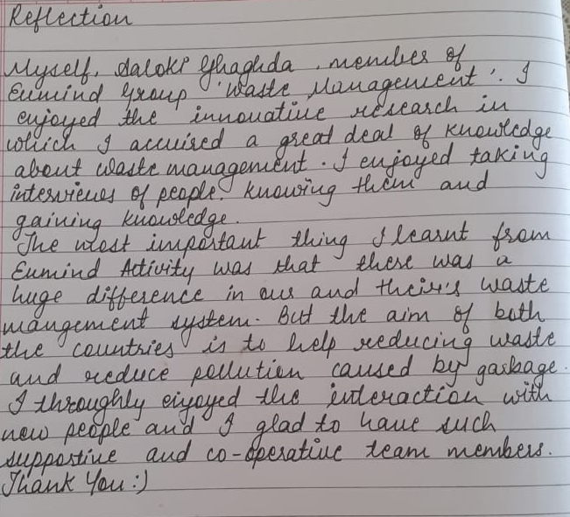AALOKI GHAGHDA

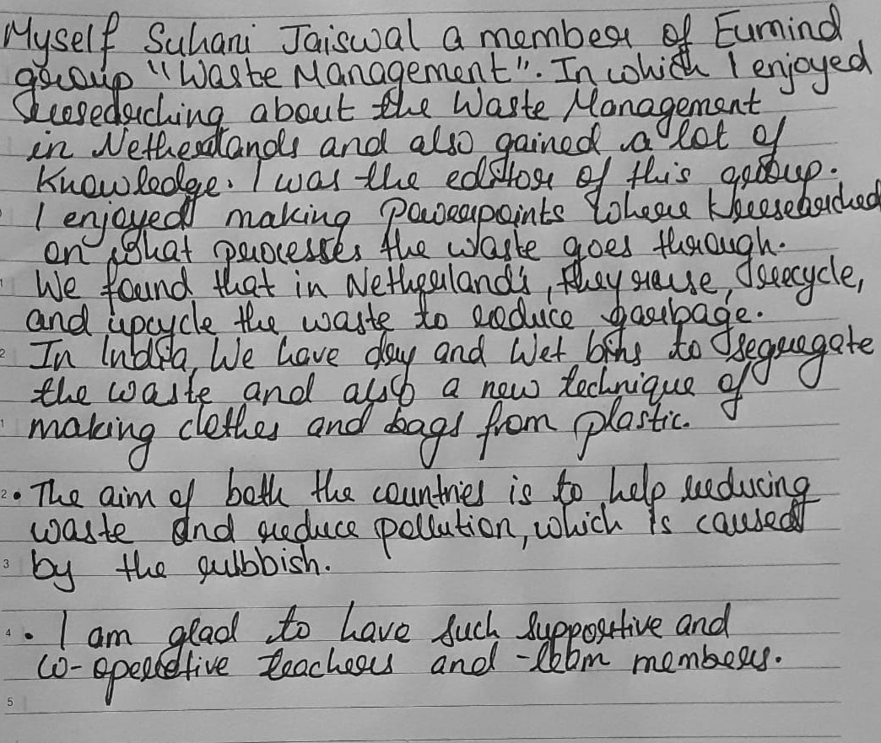SUHANI JAISWAL

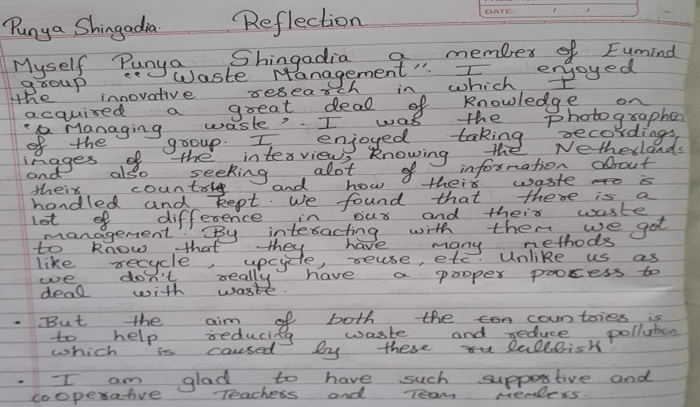PUNYA SHINGADIA

DRISHTI JANGID

Myself Drishti Jangid, a member of Eumind group "Waste Management". I enjoyed the innovative research in which I gained a lot of knowledge about the waste management system. I was the writer of the group. I enjoyed writing summaries and questions and gained knowledge about the Netherland students. But the aim of both the countries is to help reducing waste and pollution which is caused by the rubbish I am glad to have such supportive and co-operative teachers and team members.

