**EUMIND - PHASE IV**

**MY GREEN TRIPS**

**SUMMARY**

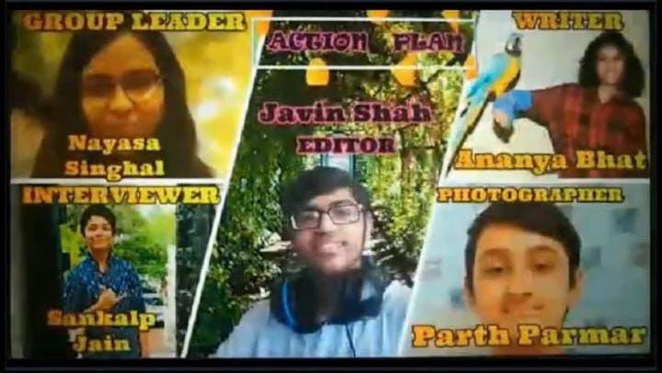

**SURVEY-**

**SIMILARITIES & DIFFERENCES**

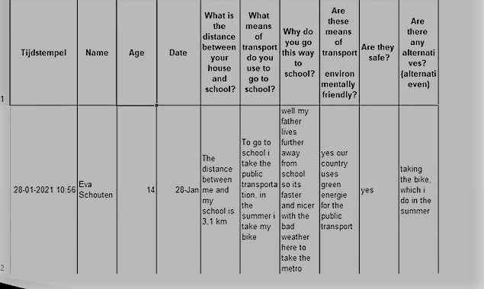

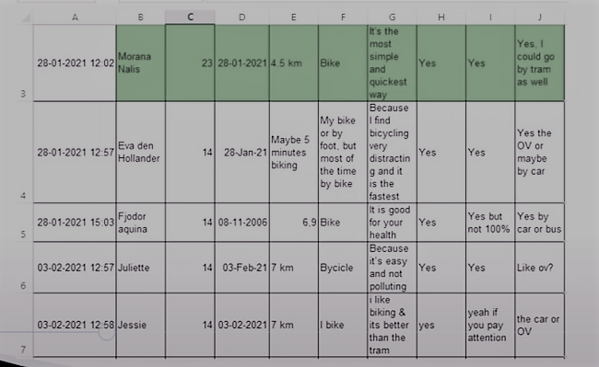

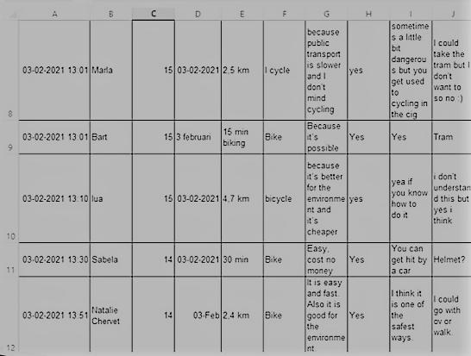

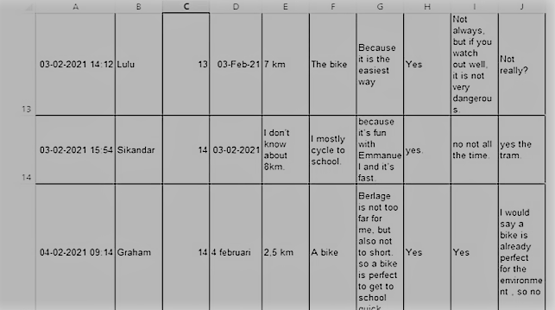

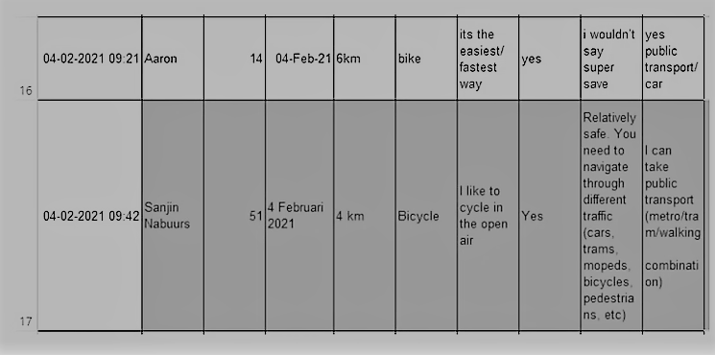

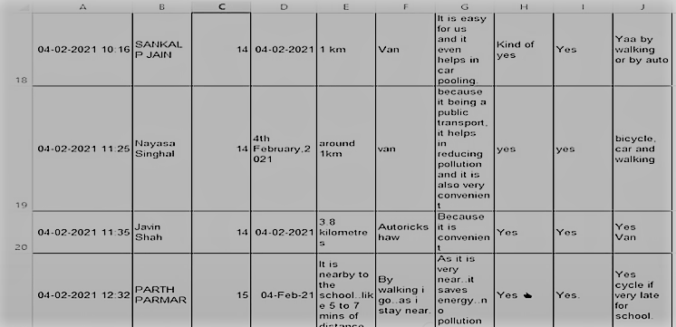

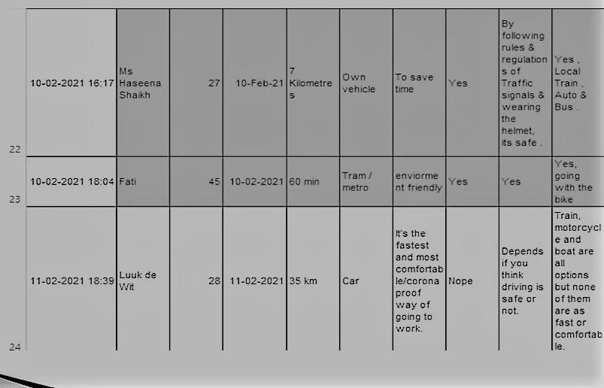

**TEAM VIEWS SIMILARITIES &**

**DIFFERENCES.**

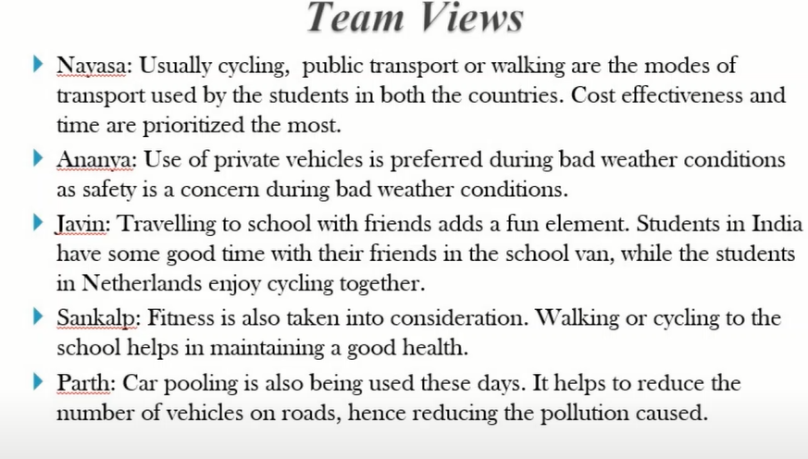

**SIMILARITIES & DIFFERENCES- OVERVIEW**

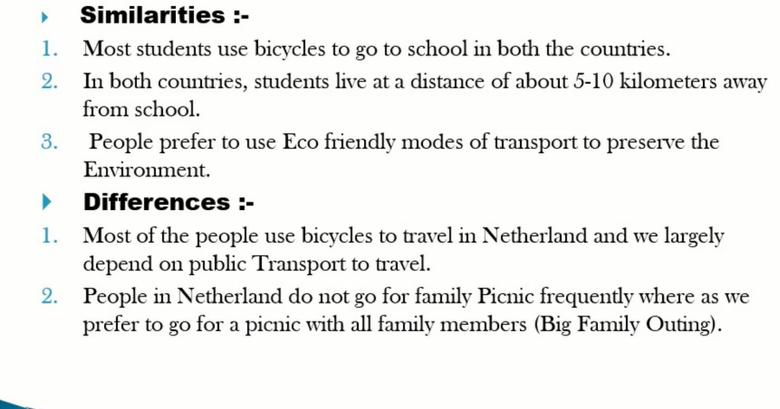

**REFLECTION**

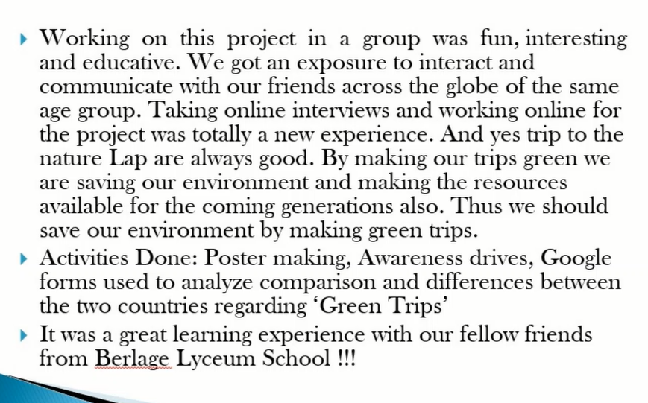

**THANK YOU**